**Date:**

**EXPERIMENT-17**

**MAKE A COMPUTER LAB TO TRANSFER A MESSAGE FROM ONE NODE TO ANOTHER TO DESIGN AND SIMULATE USING CISCO PACKET TRACER**

**Aim:** To make a Computer Lab to transfer a message from one node to another to design and simulate using Cisco Packet Tracer.

**Software/Apparatus required:** Packet Tracer/End devices, Hubs, connectors.

**Procedure:**

Step 1: Create the network topology

First, we need to create the network topology for the computer lab. In Packet Tracer, drag two computers, a switch, and two routers onto the workspace. Connect the computers to the switch using Ethernet cables, and connect the switch to the two routers using Ethernet cables. The network should look like this:

CODE:

PC1 PC2

| |

Switch -----Router1 Router2

Step 2: Configure IP addresses

Next, we will configure IP addresses for the computers. Double-click on each PC to open the configuration window and navigate to the Desktop tab. Click on the IP Configuration icon and enter the IP address and subnet mask for each computer. For example, PC1 can have an IP address of 192.168.1.1 with a subnet mask of 255.255.255.0, and PC2 can have an IP address of 192.168.1.2 with the same subnet mask.

Step 3: Configure the routers

Now, we will configure the routers. Double-click on Router1 to open the configuration window and navigate to the CLI tab. Enter the following commands:

COMMANDS:

enable

configure terminal interface FastEthernet0/0

ip address 192.168.1.254 255.255.255.0

no shutdown interface Serial0/0/0

ip address 10.0.0.1 255.255.255.252

no shutdown exit

Now, double-click on Router2 to open the configuration window and navigate to the CLI tab.

Enter the following commands enable

configure terminal interface Serial0/0/0

ip address 10.0.0.2 255.255.255.252

no shutdown

interface FastEthernet0/0

ip address 192.168.2.254 255.255.255.0

no shutdown exit

Step 4: Configure routing

We need to configure routing between the routers so that they can communicate with each other. Enter the following commands on Router1:

enable

configure terminal

ip route 192.168.2.0 255.255.255.0 10.0.0.2

exit

These commands will configure a static route on Router1 to reach the 192.168.2.0/24 network, which is connected to Router2's Fast Ethernet interface.

enable

configure terminal

ip route 192.168.1.0 255.255.255.0 10.0.0.1

exit

Step 5: Send a message

To send a message from PC1 to PC2, open the command prompt on PC1 and type: ping 192.168.1.2

**OUTPUT:**

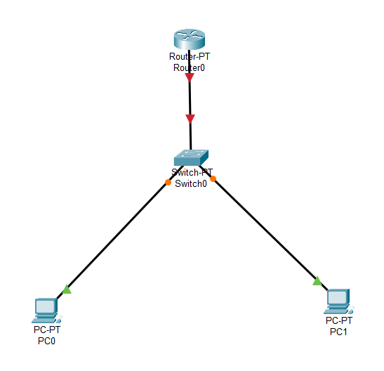

**Result:** Hence the message is transferred from one node to another to design and simulate using Cisco Packet Tracer successfully .